**Supplementary Materials 2-A**

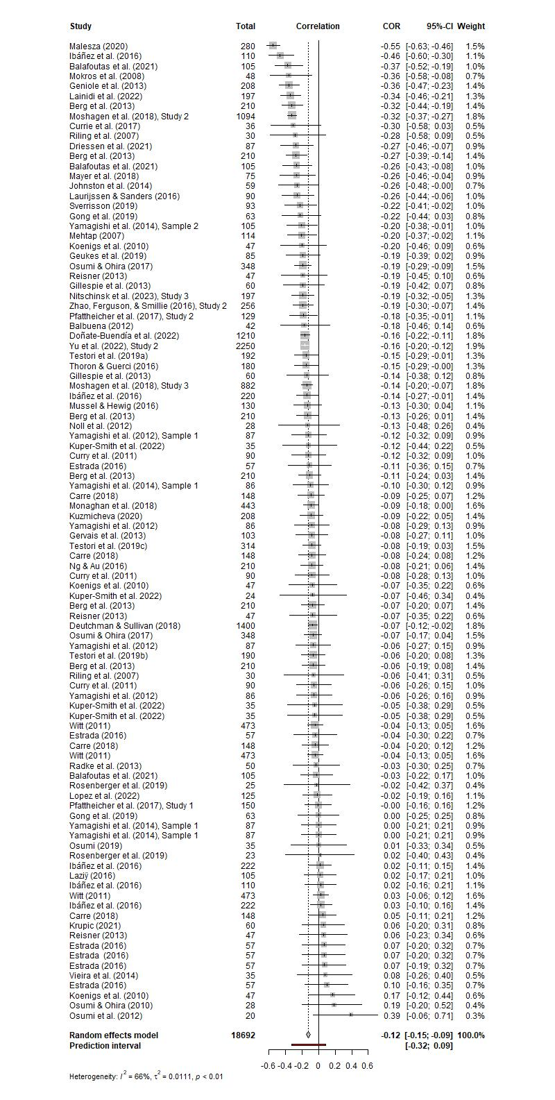**Forest Plot for the Collapsed Meta-Analytic Model**

Note: The models used for all forest plots are simple random-effects models that does not explicitly model for dependency across studies (i.e., via a multi-level meta-analytic model). Unfortunately, there does not yet exist a package for generating forest plots for multi-level meta-analytic models. This accounts for the slight deviations in cumulative effect size estimates.

**Supplementary Materials 2-B**

**Funnel Plot for the Collapsed Meta-Analytic Model**

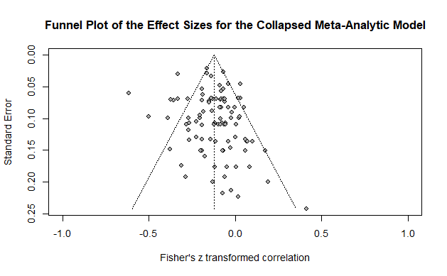

**Supplementary Materials 2-C**

**Moderator Analyses for the Collapsed Model**

**Table 1**

*Simple Meta-Regression Predicting Effect Size from Study Sample Size (N)*

|  |  |  |  |  |  |  |
| --- | --- | --- | --- | --- | --- | --- |
| Variable | *b* | *SE* | *t* | *p* | 95% CI | |
|  |  |  |  |  | LL | UL |
| Intercept | -0.12 | 0.02 | -6.19 | < .001 | -0.16 | -0.08 |
| Study *N* | -0.00 | 0.00 | -0.89 | .376 | -0.00 | 0.00 |

*Note*. The omnibus test for this moderator was not significant, *F*(1, 96) = 0.79, *p* = .376, *k* = 98. *b* = unstandardized regression coefficient; *SE* = standard error; *p* = p-value; CI = confidence interval; LL = lower limit; UL = upper limit.

**Table 2**

*Simple Meta-Regression Predicting Effect Size from Sex Composition of Study (Expressed as the Percentage of Female Participants)*

|  |  |  |  |  |  |  |
| --- | --- | --- | --- | --- | --- | --- |
| Variable | *b* | *SE* | *t* | *p* | 95% CI | |
|  |  |  |  |  | LL | UL |
| Intercept | -0.11 | 0.03 | -3.29 | .001 | -0.18 | -0.05 |
| Female Proportion | -0.03 | 0.07 | -0.45 | .656 | -0.16 | 0.10 |

*Note*. The omnibus test for this moderator was not significant, *F*(1, 94) = 0.19, *p* = .656, *k* = 96. *b* = unstandardized regression coefficient; *SE* = standard error; *p* = p-value; CI = confidence interval; LL = lower limit; UL = upper limit.

**Table 3**

*Simple Meta-Regression Predicting Effect Size from Average Sample Age in Study*

|  |  |  |  |  |  |  |
| --- | --- | --- | --- | --- | --- | --- |
| Variable | *b* | *SE* | *t* | *p* | 95% CI | |
|  |  |  |  |  | LL | UL |
| Intercept | -0.09 | 0.06 | -1.41 | .163 | -0.22 | 0.04 |
| Average Age | -0.00 | 0.00 | -0.71 | .480 | -0.01 | 0.00 |

*Note*. The omnibus test for this moderator was not significant, *F*(1, 78) = 0.50, *p* = .480, *k* = 80. *b* = unstandardized regression coefficient; *SE* = standard error; *p* = p-value; CI = confidence interval; LL = lower limit; UL = upper limit.

**Table 4**

*Simple Meta-Regression Predicting Effect Size from Sample Source*

|  |  |  |  |  |  |  |
| --- | --- | --- | --- | --- | --- | --- |
| Variable | *b* | *SE* | *t* | *p* | 95% CI | |
|  |  |  |  |  | LL | UL |
| Intercept | -0.15 | 0.03 | -5.49 | < .001 | -0.20 | -0.10 |
| Student | 0.04 | 0.04 | 1.14 | .258 | -0.03 | 0.11 |
| Inmate | 0.04 | 0.06 | 0.60 | .550 | -0.09 | 0.17 |
| Mixed | -0.17 | 0.12 | -1.34 | .183 | -0.41 | 0.08 |

*Note*. The omnibus test for this moderator was not significant, *F*(3, 91) = 1.27, *p* = .290, *k* = 95. Community samples were the reference category (i.e., the intercept). *b* = unstandardized regression coefficient; *SE* = standard error; *p* = p-value; CI = confidence interval; LL = lower limit; UL = upper limit.

**Table 5**

*Simple Meta-Regression Predicting Effect Size from Publication Status*

|  |  |  |  |  |  |  |
| --- | --- | --- | --- | --- | --- | --- |
| Variable | *b* | *SE* | *t* | *p* | 95% CI | |
|  |  |  |  |  | LL | UL |
| Intercept | -0.06 | 0.03 | -2.06 | .042 | -0.12 | -0.00 |
| Published | -0.09 | 0.03 | -2.59 | .011 | -0.15 | -0.02 |

*Note*. The omnibus test for this moderator was significant, *F*(1, 96) = 6.71, *p* = .011, *k* = 98. Unpublished samples were the reference category (i.e., the intercept). *b* = unstandardized regression coefficient; *SE* = standard error; *p* = p-value; CI = confidence interval; LL = lower limit; UL = upper limit.

**Table 6**

*Simple Meta-Regression Predicting Effect Size from Psychopathy Measure Used*

|  |  |  |  |  |  |  |
| --- | --- | --- | --- | --- | --- | --- |
| Variable | *b* | *SE* | *t* | *p* | 95% CI | |
|  |  |  |  |  | LL | UL |
| Intercept | -0.13 | 0.04 | -3.45 | < .001 | -0.20 | -0.05 |
| PCL | 0.08 | 0.08 | 0.96 | .340 | -0.08 | 0.24 |
| PPI | -0.01 | 0.05 | -0.13 | .893 | -0.11 | 0.10 |
| LSRP | -0.01 | 0.05 | -0.21 | .838 | -0.11 | 0.09 |
| TriPM | 0.05 | 0.09 | 0.57 | .567 | -0.13 | 0.24 |
| SD3 | 0.01 | 0.05 | 0.26 | .793 | -0.09 | 0.12 |
| DD | -0.07 | 0.07 | -0.95 | .343 | -0.21 | 0.07 |

*Note*. The omnibus test for this moderator was not significant, *F*(6, 88) = 0.50, *p* = .805, *k* = 95. Samples using the Self Report Psychopathy Scale (and its successor versions) were the reference category (i.e., the intercept). *b* = unstandardized regression coefficient; *SE* = standard error; *p* = p-value; CI = confidence interval; LL = lower limit; UL = upper limit; PCL = Psychopathy Checklist; PPI = Psychopathic Personality Inventory; LSRP = Levenson Self-Report Psychopathy Scale; TriPM = Triarchic Psychopathy Measure; SD3 = Short Dark Triad; DD = Dirty Dozen.

**Table 7**

*Simple Meta-Regression Predicting Effect Size from Game Type*

|  |  |  |  |  |  |  |
| --- | --- | --- | --- | --- | --- | --- |
| Variable | *b* | *SE* | *t* | *p* | 95% CI | |
|  |  |  |  |  | LL | UL |
| Intercept | -0.15 | 0.03 | -6.00 | < .001 | -0.20 | -0.10 |
| PGG | 0.07 | 0.06 | 1.13 | .263 | -0.05 | 0.18 |
| DG | -0.01 | 0.04 | -0.36 | .720 | -0.09 | 0.06 |
| UG-P | 0.09 | 0.05 | 1.75 | .083 | -0.01 | 0.19 |
| UG-R | 0.11 | 0.04 | 2.38 | .019 | 0.02 | 0.20 |
| TG-P | 0.15 | 0.08 | 2.04 | .045 | 0.00 | 0.30 |
| TG-R | -0.05 | 0.06 | -0.90 | .369 | -0.17 | 0.06 |

*Note*. The omnibus test for this moderator was significant, *F*(6, 91) = 2.77, *p* = .016, *k* = 98. Samples using the Prisoner’s Dilemma Game as an economic game were the reference category (i.e., the intercept). *b* = unstandardized regression coefficient; *SE* = standard error; *p* = p-value; CI = confidence interval; LL = lower limit; UL = upper limit; PGG = Public Goods Game; DG = Dictator Game; UG-P = Ultimatum Game – Proposer; UG-R = Ultimatum Game Responder; TG-P = Trust Game Proposer; TG-R = Trust Game Responder.

**Table 8**

*Simple Meta-Regression Predicting Effect Size from Game Length (One-Shot vs. Iterated)*

|  |  |  |  |  |  |  |
| --- | --- | --- | --- | --- | --- | --- |
| Variable | *b* | *SE* | *t* | *p* | 95% CI | |
|  |  |  |  |  | LL | UL |
| Intercept | -0.11 | 0.02 | -6.61 | < .001 | -0.14 | -0.08 |
| Iterated | -0.05 | 0.03 | -1.58 | .117 | -0.12 | 0.01 |

*Note*. The omnibus test for this moderator was not significant, *F*(1, 94) = 2.50, *p* = .117, *k* = 96. Samples with a one-shot game were the reference category (i.e., the intercept). *b* = unstandardized regression coefficient; *SE* = standard error; *p* = p-value; CI = confidence interval; LL = lower limit; UL = upper limit.

**Table 9**

*Simple Meta-Regression Predicting Effect Size from Perceived Opponent*

|  |  |  |  |  |  |  |
| --- | --- | --- | --- | --- | --- | --- |
| Variable | *b* | *SE* | *t* | *p* | 95% CI | |
|  |  |  |  |  | LL | UL |
| Intercept | -0.19 | 0.03 | -6.38 | < .001 | -0.24 | -0.13 |
| Human | 0.09 | 0.03 | 2.55 | .012 | 0.02 | 0.15 |

*Note*. The omnibus test for this moderator was significant, *F*(1, 91) = 6.50, *p* = .012, *k* = 93. Samples where participants were not led to believe that their opponent was human were the reference category (i.e., the intercept). *b* = unstandardized regression coefficient; *SE* = standard error; *p* = p-value; CI = confidence interval; LL = lower limit; UL = upper limit.

**Table 10**

*Simple Meta-Regression Predicting Effect Size from the Social Role of Opponents*

|  |  |  |  |  |  |  |
| --- | --- | --- | --- | --- | --- | --- |
| Variable | *b* | *SE* | *t* | *p* | 95% CI | |
|  |  |  |  |  | LL | UL |
| Intercept | -0.05 | 0.07 | -0.79 | .431 | -0.19 | 0.08 |
| Distant Member | -0.06 | 0.07 | -0.79 | .431 | -0.20 | 0.08 |

*Note*. The omnibus test for this moderator was not significant, *F*(1, 74) = 0.63, *p* = .431, *k* = 76. Samples where participants were told that their opponent was someone in their immediate social circle (e.g., friend, in-group member) were the reference category (i.e., the intercept). *b* = unstandardized regression coefficient; *SE* = standard error; *p* = p-value; CI = confidence interval; LL = lower limit; UL = upper limit.

**Table 11**

*Simple Meta-Regression Predicting Effect Size from the Incentive Structure of the Study*

|  |  |  |  |  |  |  |
| --- | --- | --- | --- | --- | --- | --- |
| Variable | *b* | *SE* | *t* | *p* | 95% CI | |
|  |  |  |  |  | LL | UL |
| Intercept | -0.26 | 0.04 | -6.05 | < .001 | -0.35 | -0.17 |
| Participation Incentivized | 0.11 | 0.05 | 2.19 | .031 | 0.01 | 0.21 |
| Performance Incentivized | 0.17 | 0.05 | 3.68 | < .001 | 0.08 | 0.27 |

*Note*. The omnibus test for this moderator was significant, *F*(2, 82) = 7.45, *p* = .001, *k* = 85. Samples where participants were not incentivized were the reference category (i.e., the intercept). *b* = unstandardized regression coefficient; *SE* = standard error; *p* = p-value; CI = confidence interval; LL = lower limit; UL = upper limit.

**Table 12**

*Simple Meta-Regression Predicting Effect Size from Participant Feedback in Study*

|  |  |  |  |  |  |  |
| --- | --- | --- | --- | --- | --- | --- |
| Variable | *b* | *SE* | *t* | *p* | 95% CI | |
|  |  |  |  |  | LL | UL |
| Intercept | -0.08 | 0.04 | -2.01 | .051 | -0.17 | 0.00 |
| Feedback Provided | -0.06 | 0.06 | -1.03 | .308 | -0.17 | 0.06 |

*Note*. The omnibus test for this moderator was not significant, *F*(1, 39) = 1.07, *p* = .308, *k* = 41. Samples where participants were not provided feedback based on their decisions were the reference category (i.e., the intercept). *b* = unstandardized regression coefficient; *SE* = standard error; *p* = p-value; CI = confidence interval; LL = lower limit; UL = upper limit.

**Table 12**

*Simple Meta-Regression Predicting Effect Size from Opponent Strategy in Study*

|  |  |  |  |  |  |  |
| --- | --- | --- | --- | --- | --- | --- |
| Variable | *b* | *SE* | *t* | *p* | 95% CI | |
|  |  |  |  |  | LL | UL |
| Intercept | -0.12 | 0.03 | -3.49 | .002 | -0.18 | -0.05 |
| TFT | -0.01 | 0.08 | -0.10 | .925 | -0.18 | 0.16 |
| TF2T | -0.04 | 0.07 | -0.51 | .617 | -0.19 | 0.11 |
| Neutral/SeeSaw | -0.20 | 0.20 | -1.01 | .323 | -0.60 | 0.21 |
| Replicator | -0.24 | 0.12 | -2.06 | .049 | -0.48 | -0.00 |

*Note*. The omnibus test for this moderator was not significant, *F*(4, 27) = 1.29, *p* = .298, *k* = 32. Samples where participants played against a live opponent were the reference category (i.e., the intercept). *b* = unstandardized regression coefficient; *SE* = standard error; *p* = p-value; CI = confidence interval; LL = lower limit; UL = upper limit.

**Table 13**

*Simple Meta-Regression Predicting Effect Size from Opponent Leniency in Study*

|  |  |  |  |  |  |  |
| --- | --- | --- | --- | --- | --- | --- |
| Variable | *b* | *SE* | *t* | *p* | 95% CI | |
|  |  |  |  |  | LL | UL |
| Intercept | -0.13 | 0.04 | -3.05 | .011 | -0.22 | -0.04 |
| Neutral | -0.01 | 0.07 | -0.11 | .914 | -0.16 | 0.15 |

*Note*. The omnibus test for this moderator was not significant, *F*(1, 11) = 0.012, *p* = .611, *k* = 13. Samples where participants played against “lenient” strategy (e.g., Always Cooperate, TF2T, TF3T) were the reference category (i.e., the intercept). *b* = unstandardized regression coefficient; *SE* = standard error; *p* = p-value; CI = confidence interval; LL = lower limit; UL = upper limit.

**Supplementary Materials 2-D**

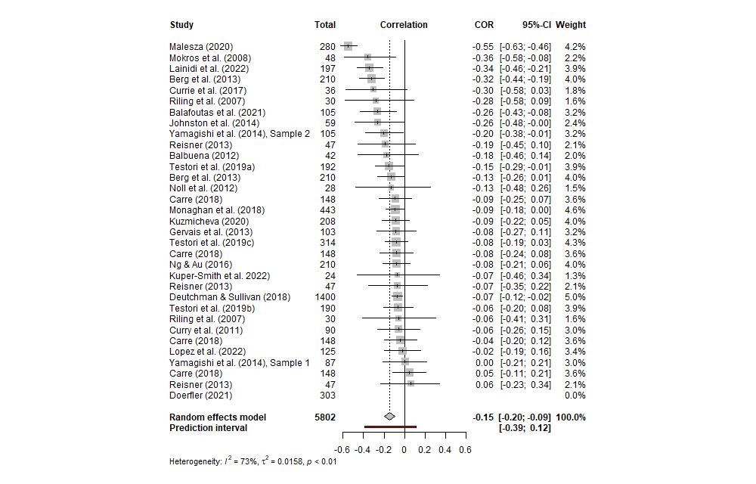**Forest Plot for the Meta-Analytic Model Examining Psychopathy in the PDG**

**Supplementary Materials 2-E**

**Funnel Plot for the PDG Meta-Analytic Model**

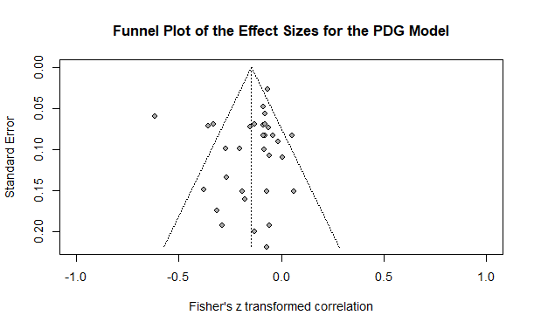

**Supplementary Materials 2-F**

**Moderator Analyses for the PDG Meta-Analytic Model**

**Table 1**

*Simple Meta-Regression Predicting Effect Size from Study Sample Size (N)*

|  |  |  |  |  |  |  |
| --- | --- | --- | --- | --- | --- | --- |
| Variable | *b* | *SE* | *t* | *p* | 95% CI | |
|  |  |  |  |  | LL | UL |
| Intercept | -0.17 | 0.04 | -4.21 | < .001 | -0.25 | -0.09 |
| Study *N* | 0.00 | 0.00 | 0.52 | .607 | -0.00 | 0.00 |

*Note*. The omnibus test for this moderator was not significant, *F*(1, 30) = 0.27, *p* = .607, *k* = 32. *b* = unstandardized regression coefficient; *SE* = standard error; *p* = p-value; CI = confidence interval; LL = lower limit; UL = upper limit.

**Table 2**

*Simple Meta-Regression Predicting Effect Size from Sex Composition of Study (Expressed as the Percentage of Female Participants)*

|  |  |  |  |  |  |  |
| --- | --- | --- | --- | --- | --- | --- |
| Variable | *b* | *SE* | *t* | *p* | 95% CI | |
|  |  |  |  |  | LL | UL |
| Intercept | -0.19 | 0.07 | -2.69 | .012 | -0.33 | -0.04 |
| Female Proportion | 0.05 | 0.13 | 0.40 | .695 | -0.22 | 0.32 |

*Note*. The omnibus test for this moderator was not significant, *F*(1, 29) = 0.16, *p* = .695, *k* = 31. *b* = unstandardized regression coefficient; *SE* = standard error; *p* = p-value; CI = confidence interval; LL = lower limit; UL = upper limit.

**Table 3**

*Simple Meta-Regression Predicting Effect Size from Average Sample Age in Study*

|  |  |  |  |  |  |  |
| --- | --- | --- | --- | --- | --- | --- |
| Variable | *b* | *SE* | *t* | *p* | 95% CI | |
|  |  |  |  |  | LL | UL |
| Intercept | -0.03 | 0.13 | -0.23 | .822 | -0.29 | 0.23 |
| Average Age | -0.01 | 0.00 | -1.13 | .269 | -0.01 | 0.00 |

*Note*. The omnibus test for this moderator was not significant, *F*(1, 27) = 1.27, *p* = .269, *k* = 29. *b* = unstandardized regression coefficient; *SE* = standard error; *p* = p-value; CI = confidence interval; LL = lower limit; UL = upper limit.

**Table 4**

*Simple Meta-Regression Predicting Effect Size from Sample Source*

|  |  |  |  |  |  |  |
| --- | --- | --- | --- | --- | --- | --- |
| Variable | *b* | *SE* | *t* | *p* | 95% CI | |
|  |  |  |  |  | LL | UL |
| Intercept | -0.17 | 0.05 | -3.78 | < .001 | -0.27 | -0.08 |
| Student | 0.05 | 0.07 | 0.74 | .464 | -0.09 | 0.20 |
| Inmate | -0.04 | 0.15 | -0.26 | .799 | -0.34 | 0.26 |
| Mixed | -0.20 | 0.21 | -0.98 | .334 | -0.63 | 0.22 |

*Note*. The omnibus test for this moderator was not significant, *F*(3, 27) = 0.64, *p* = .598, *k* = 31. Community samples were the reference category (i.e., the intercept). *b* = unstandardized regression coefficient; *SE* = standard error; *p* = p-value; CI = confidence interval; LL = lower limit; UL = upper limit.

**Table 5**

*Simple Meta-Regression Predicting Effect Size from Publication Status*

|  |  |  |  |  |  |  |
| --- | --- | --- | --- | --- | --- | --- |
| Variable | *b* | *SE* | *t* | *p* | 95% CI | |
|  |  |  |  |  | LL | UL |
| Intercept | -0.07 | 0.08 | -0.91 | 0.368 | -0.24 | 0.09 |
| Published | -0.10 | 0.09 | -1.16 | 0.257 | -0.28 | 0.08 |

*Note*. The omnibus test for this moderator was significant, *F*(1, 30) = 1.34, *p* = .257, *k* = 32. Unpublished samples were the reference category (i.e., the intercept). *b* = unstandardized regression coefficient; *SE* = standard error; *p* = p-value; CI = confidence interval; LL = lower limit; UL = upper limit.

**Table 6**

*Simple Meta-Regression Predicting Effect Size from Psychopathy Measure Used*

|  |  |  |  |  |  |  |
| --- | --- | --- | --- | --- | --- | --- |
| Variable | *b* | *SE* | *t* | *p* | 95% CI | |
|  |  |  |  |  | LL | UL |
| Intercept | -0.28 | 0.08 | -3.53 | .002 | -0.45 | -0.12 |
| PCL | 0.21 | 0.27 | 0.79 | .436 | -0.34 | 0.76 |
| PPI | 0.13 | 0.1 | 1.26 | .221 | -0.08 | 0.33 |
| LSRP | 0.12 | 0.1 | 1.24 | .228 | -0.08 | 0.32 |
| TriPM | 0.20 | 0.16 | 1.26 | .221 | -0.13 | 0.54 |
| SD3 | 0.19 | 0.09 | 2.05 | .051 | 0.00 | 0.38 |
| DD | 0.12 | 0.12 | 1.01 | .324 | -0.13 | 0.36 |

*Note*. The omnibus test for this moderator was not significant, *F*(6, 24) = 0.79, *p* = .584, *k* = 31. Samples using the Self Report Psychopathy Scale (and its successor versions) were the reference category (i.e., the intercept). *b* = unstandardized regression coefficient; *SE* = standard error; *p* = p-value; CI = confidence interval; LL = lower limit; UL = upper limit; PCL = Psychopathy Checklist; PPI = Psychopathic Personality Inventory; LSRP = Levenson Self-Report Psychopathy Scale; TriPM = Triarchic Psychopathy Measure; SD3 = Short Dark Triad; DD = Dirty Dozen.

**Table 7**

*Simple Meta-Regression Predicting Effect Size from Game Length (One-Shot vs. Iterated)*

|  |  |  |  |  |  |  |
| --- | --- | --- | --- | --- | --- | --- |
| Variable | *b* | *SE* | *t* | *p* | 95% CI | |
|  |  |  |  |  | LL | UL |
| Intercept | -0.11 | 0.04 | -2.69 | .012 | -0.19 | -0.03 |
| Iterated | -0.11 | 0.06 | -1.80 | .082 | -0.23 | 0.01 |

*Note*. The omnibus test for this moderator trended towards significance, *F*(1, 30) = 3.25, *p* = .081, *k* = 32. Samples with a one-shot game were the reference category (i.e., the intercept). *b* = unstandardized regression coefficient; *SE* = standard error; *p* = p-value; CI = confidence interval; LL = lower limit; UL = upper limit.

**Table 8**

*Simple Meta-Regression Predicting Effect Size from Perceived Opponent*

|  |  |  |  |  |  |  |
| --- | --- | --- | --- | --- | --- | --- |
| Variable | *b* | *SE* | *t* | *p* | 95% CI | |
|  |  |  |  |  | LL | UL |
| Intercept | -0.25 | 0.07 | -3.38 | .002 | -0.39 | -0.10 |
| Human | 0.11 | 0.08 | 1.34 | .190 | -0.06 | 0.28 |

*Note*. The omnibus test for this moderator was significant, *F*(1, 29) = 1.81, *p* = .190, *k* = 31. Samples where participants were not led to believe that their opponent was human were the reference category (i.e., the intercept). *b* = unstandardized regression coefficient; *SE* = standard error; *p* = p-value; CI = confidence interval; LL = lower limit; UL = upper limit.

**Table 9**

*Simple Meta-Regression Predicting Effect Size from the Social Role of Opponents*

|  |  |  |  |  |  |  |
| --- | --- | --- | --- | --- | --- | --- |
| Variable | *b* | *SE* | *t* | *p* | 95% CI | |
|  |  |  |  |  | LL | UL |
| Intercept | -0.04 | 0.07 | -0.48 | .636 | -0.19 | 0.12 |
| Distant Member | -0.10 | 0.07 | -1.45 | .161 | -0.25 | 0.04 |

*Note*. The omnibus test for this moderator was not significant, *F*(1, 22) = 2.11, *p* = .161, *k* = 24. Samples where participants were told that their opponent was someone in their immediate social circle (e.g., friend, in-group member) were the reference category (i.e., the intercept). *b* = unstandardized regression coefficient; *SE* = standard error; *p* = p-value; CI = confidence interval; LL = lower limit; UL = upper limit.

**Table 10**

*Simple Meta-Regression Predicting Effect Size from the Incentive Structure of the Study*

|  |  |  |  |  |  |  |
| --- | --- | --- | --- | --- | --- | --- |
| Variable | *b* | *SE* | *t* | *p* | 95% CI | |
|  |  |  |  |  | LL | UL |
| Intercept | -0.30 | 0.07 | -4.08 | < .001 | -0.46 | -0.15 |
| Participation Incentivized | 0.15 | 0.09 | 1.63 | .119 | -0.04 | 0.34 |
| Performance Incentivized | 0.21 | 0.09 | 2.28 | .033 | 0.02 | 0.40 |

*Note*. The omnibus test for this moderator trended towards significance, *F*(2, 21) = 2.61, *p* = .097, *k* = 24. Samples where participants were not incentivized were the reference category (i.e., the intercept). *b* = unstandardized regression coefficient; *SE* = standard error; *p* = p-value; CI = confidence interval; LL = lower limit; UL = upper limit.

**Table 11**

*Simple Meta-Regression Predicting Effect Size from the k-index of the PDG*

|  |  |  |  |  |  |  |
| --- | --- | --- | --- | --- | --- | --- |
| Variable | *b* | *SE* | *t* | *p* | 95% CI | |
|  |  |  |  |  | LL | UL |
| Intercept | -0.03 | 0.10 | -0.30 | .765 | -0.25 | 0.18 |
| *k*-index | -0.30 | 0.24 | -1.23 | .232 | -0.80 | 0.20 |

*Note*. The omnibus test for this moderator was not significant, *F*(1, 24) = 1.51, *p* = .232, *k* = 26. *b* = unstandardized regression coefficient; *SE* = standard error; *p* = p-value; CI = confidence interval; LL = lower limit; UL = upper limit.

**Table 12**

*Simple Meta-Regression Predicting Effect Size from Participant Feedback in Study*

|  |  |  |  |  |  |  |
| --- | --- | --- | --- | --- | --- | --- |
| Variable | *b* | *SE* | *t* | *p* | 95% CI | |
|  |  |  |  |  | LL | UL |
| Intercept | -0.07 | 0.06 | -1.33 | .199 | -0.19 | 0.04 |
| Feedback Provided | -0.16 | 0.08 | -2.09 | .048 | -0.32 | 0.00 |

*Note*. The omnibus test for this moderator was significant, *F*(1, 22) = 4.39, *p* = .048, *k* = 24. Samples where participants were not provided feedback based on their decisions were the reference category (i.e., the intercept). *b* = unstandardized regression coefficient; *SE* = standard error; *p* = p-value; CI = confidence interval; LL = lower limit; UL = upper limit.

**Table 13**

*Simple Meta-Regression Predicting Effect Size from Opponent Strategy in Study*

|  |  |  |  |  |  |  |
| --- | --- | --- | --- | --- | --- | --- |
| Variable | *b* | *SE* | *t* | *p* | 95% CI | |
|  |  |  |  |  | LL | UL |
| Intercept | -0.07 | 0.03 | -2.52 | .022 | -0.12 | -0.01 |
| TFT | -0.07 | 0.07 | -1.00 | .332 | -0.22 | 0.08 |
| TF2T | -0.06 | 0.05 | -1.24 | .230 | -0.17 | 0.04 |
| Neutral/SeeSaw | -0.25 | 0.18 | -1.40 | .179 | -0.62 | 0.12 |
| Replicator | -0.29 | 0.08 | -3.77 | < .001 | -0.45 | -0.13 |

*Note*. The omnibus test for this moderator was significant, *F*(4, 18) = 3.99, *p* = .017, *k* = 23. Samples where participants played against a live opponent were the reference category (i.e., the intercept). *b* = unstandardized regression coefficient; *SE* = standard error; *p* = p-value; CI = confidence interval; LL = lower limit; UL = upper limit.

**Table 14**

*Simple Meta-Regression Predicting Effect Size from Opponent Leniency in Study*

|  |  |  |  |  |  |  |
| --- | --- | --- | --- | --- | --- | --- |
| Variable | *b* | *SE* | *t* | *p* | 95% CI | |
|  |  |  |  |  | LL | UL |
| Intercept | -0.14 | 0.05 | -2.90 | .018 | -0.24 | -0.03 |
| Neutral | -0.03 | 0.08 | -0.34 | .739 | -0.20 | 0.15 |

*Note*. The omnibus test for this moderator was not significant, *F*(1, 9) = 0.12, *p* = .74, *k* = 11. Samples where participants played against “lenient” strategy (e.g., Always Cooperate, TF2T, TF3T) were the reference category (i.e., the intercept). *b* = unstandardized regression coefficient; *SE* = standard error; *p* = p-value; CI = confidence interval; LL = lower limit; UL = upper limit.

**Supplementary Materials 2-G**

**Forest Plot for the Meta-Analytic Model Examining Psychopathy in the PGG**

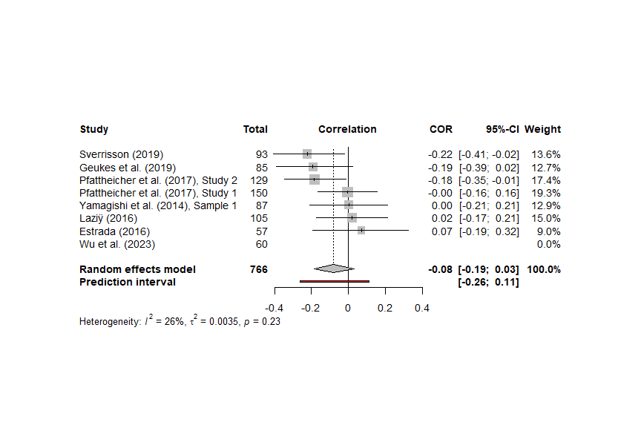

**Supplementary Materials 2-H**

**Funnel Plot for the PGG Meta-Analytic Model**

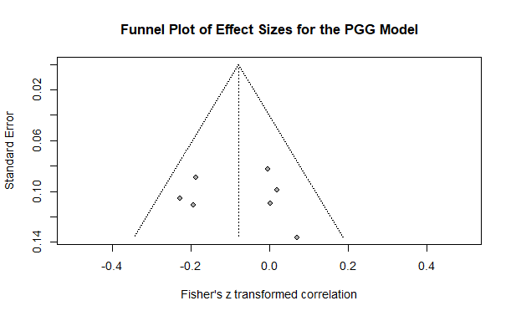

**Supplementary Materials 2-I**

**Forest Plot for the Meta-Analytic Model Examining Psychopathy in the DG**

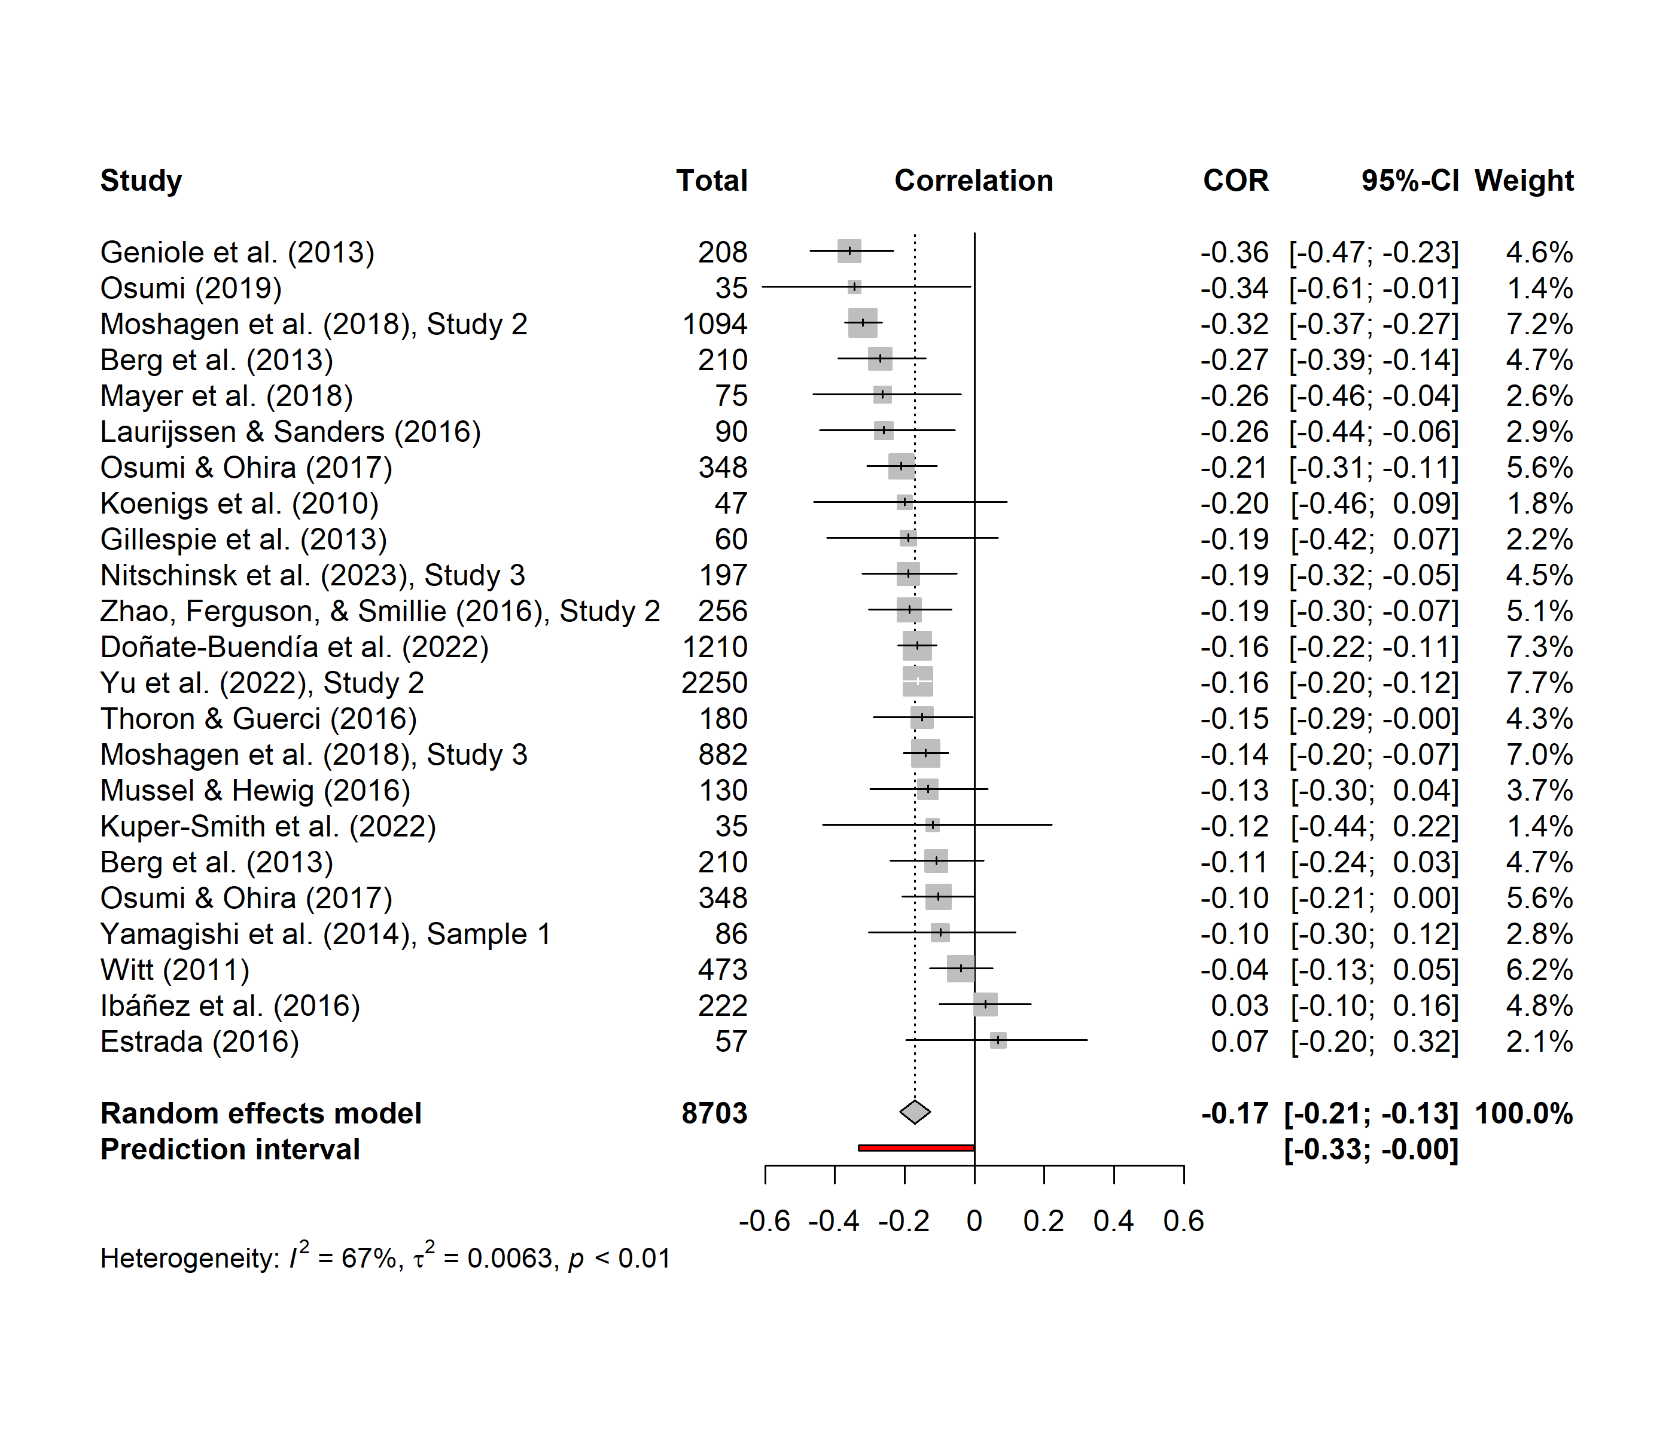

**Supplementary Materials 2-J**

**Funnel Plot for the DG Meta-Analytic Model**

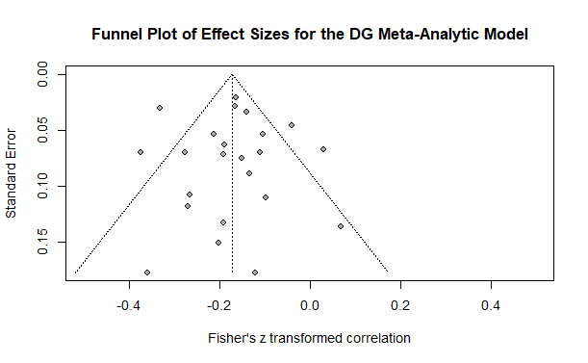

**Supplementary Materials 2-K**

**Moderator Analyses for the DG Meta-Analytic Model**

**Table 1**

*Simple Meta-Regression Predicting Effect Size from Study Sample Size (N)*

|  |  |  |  |  |  |  |
| --- | --- | --- | --- | --- | --- | --- |
| Variable | *b* | *SE* | *t* | *p* | 95% CI | |
|  |  |  |  |  | LL | UL |
| Intercept | -0.17 | 0.03 | -5.27 | < .001 | -0.23 | -0.10 |
| Study *N* | 0.00 | 0.00 | -0.29 | .771 | 0.00 | 0.00 |

*Note*. The omnibus test for this moderator was not significant, *F*(1, 21) = 0.09, *p* = .771, *k* = 23. *b* = unstandardized regression coefficient; *SE* = standard error; *p* = p-value; CI = confidence interval; LL = lower limit; UL = upper limit.

**Table 2**

*Simple Meta-Regression Predicting Effect Size from Sex Composition of Study (Expressed as the Percentage of Female Participants)*

|  |  |  |  |  |  |  |
| --- | --- | --- | --- | --- | --- | --- |
| Variable | *b* | *SE* | *t* | *p* | 95% CI | |
|  |  |  |  |  | LL | UL |
| Intercept | -0.17 | 0.07 | -2.50 | .021 | -0.32 | -0.03 |
| Female Proportion | 0.00 | 0.12 | 0.00 | .998 | -0.26 | 0.26 |

*Note*. The omnibus test for this moderator was not significant, *F*(1, 20) = 0.00, *p* = .998, *k* = 22. *b* = unstandardized regression coefficient; *SE* = standard error; *p* = p-value; CI = confidence interval; LL = lower limit; UL = upper limit.

**Table 3**

*Simple Meta-Regression Predicting Effect Size from Average Sample Age in Study*

|  |  |  |  |  |  |  |
| --- | --- | --- | --- | --- | --- | --- |
| Variable | *b* | *SE* | *t* | *p* | 95% CI | |
|  |  |  |  |  | LL | UL |
| Intercept | -0.20 | 0.09 | -2.19 | .044 | -0.39 | -0.01 |
| Average Age | 0.00 | 0.00 | 0.14 | .893 | -0.01 | 0.01 |

*Note*. The omnibus test for this moderator was not significant, *F*(1, 16) = 0.02, *p* = .893, *k* = 18. *b* = unstandardized regression coefficient; *SE* = standard error; *p* = p-value; CI = confidence interval; LL = lower limit; UL = upper limit.

**Table 4**

*Simple Meta-Regression Predicting Effect Size from Sample Source*

|  |  |  |  |  |  |  |
| --- | --- | --- | --- | --- | --- | --- |
| Variable | *b* | *SE* | *t* | *p* | 95% CI | |
|  |  |  |  |  | LL | UL |
| Intercept | -0.18 | 0.04 | -4.37 | < .001 | -0.27 | -0.10 |
| Student | 0.02 | 0.06 | 0.39 | .701 | -0.10 | 0.14 |
| Inmate | 0.02 | 0.14 | 0.12 | .903 | -0.28 | 0.31 |
| Mixed | -0.09 | 0.16 | -0.55 | .589 | -0.41 | 0.24 |

*Note*. The omnibus test for this moderator was not significant, *F*(3, 17) = 0.19, *p* = .901, *k* = 21. Community samples were the reference category (i.e., the intercept). *b* = unstandardized regression coefficient; *SE* = standard error; *p* = p-value; CI = confidence interval; LL = lower limit; UL = upper limit.

**Table 5**

*Simple Meta-Regression Predicting Effect Size from Publication Status*

|  |  |  |  |  |  |  |
| --- | --- | --- | --- | --- | --- | --- |
| Variable | *b* | *SE* | *t* | *p* | 95% CI | |
|  |  |  |  |  | LL | UL |
| Intercept | -0.10 | 0.05 | -2.09 | .049 | -0.20 | 0.00 |
| Published | -0.09 | 0.05 | -1.69 | .105 | -0.20 | 0.02 |

*Note*. The omnibus test for this moderator was not significant, *F*(1, 21) = 2.86, *p* = .105, *k* = 23. Unpublished samples were the reference category (i.e., the intercept). *b* = unstandardized regression coefficient; *SE* = standard error; *p* = p-value; CI = confidence interval; LL = lower limit; UL = upper limit.

**Table 6**

*Simple Meta-Regression Predicting Effect Size from Psychopathy Measure Used*

|  |  |  |  |  |  |  |
| --- | --- | --- | --- | --- | --- | --- |
| Variable | *b* | *SE* | *t* | *p* | 95% CI | |
|  |  |  |  |  | LL | UL |
| Intercept | -0.11 | 0.06 | -1.83 | .089 | -0.24 | 0.02 |
| PCL | -0.06 | 0.15 | -0.39 | .702 | -0.37 | 0.26 |
| PPI | -0.10 | 0.09 | -1.04 | .317 | -0.30 | 0.10 |
| LSRP | -0.05 | 0.08 | -0.69 | .499 | -0.21 | 0.11 |
| TriPM | -0.03 | 0.14 | -0.18 | .862 | -0.33 | 0.28 |
| SD3 | -0.12 | 0.09 | -1.36 | .194 | -0.30 | 0.07 |
| DD | -0.16 | 0.15 | -1.01 | .329 | -0.49 | 0.18 |

*Note*. The omnibus test for this moderator was not significant, *F*(6, 14) = 0.45, *p* = .836, *k* = 21. Samples using the Self Report Psychopathy Scale (and its successor versions) were the reference category (i.e., the intercept). *b* = unstandardized regression coefficient; *SE* = standard error; *p* = p-value; CI = confidence interval; LL = lower limit; UL = upper limit; PCL = Psychopathy Checklist; PPI = Psychopathic Personality Inventory; LSRP = Levenson Self-Report Psychopathy Scale; TriPM = Triarchic Psychopathy Measure; SD3 = Short Dark Triad; DD = Dirty Dozen.

**Table 7**

*Simple Meta-Regression Predicting Effect Size from Game Length (One-Shot vs. Iterated)*

|  |  |  |  |  |  |  |
| --- | --- | --- | --- | --- | --- | --- |
| Variable | *b* | *SE* | *t* | *p* | 95% CI | |
|  |  |  |  |  | LL | UL |
| Intercept | -0.17 | 0.03 | -6.61 | < .001 | -0.22 | -0.12 |
| Iterated | -0.01 | 0.06 | -0.17 | .870 | -0.14 | 0.12 |

*Note*. The omnibus test for this moderator was not significant, *F*(1, 21) = 0.03, *p* = .870, *k* = 23. Samples with a one-shot game were the reference category (i.e., the intercept). *b* = unstandardized regression coefficient; *SE* = standard error; *p* = p-value; CI = confidence interval; LL = lower limit; UL = upper limit.

**Table 8**

*Simple Meta-Regression Predicting Effect Size from Perceived Opponent*

|  |  |  |  |  |  |  |
| --- | --- | --- | --- | --- | --- | --- |
| Variable | *b* | *SE* | *t* | *p* | 95% CI | |
|  |  |  |  |  | LL | UL |
| Intercept | -0.21 | 0.03 | -6.21 | < .001 | -0.28 | -0.14 |
| Human | 0.06 | 0.04 | 1.45 | .163 | -0.03 | 0.16 |

*Note*. The omnibus test for this moderator was not significant, *F*(1, 21) = 2.09, *p* = .163, *k* = 23. Samples where participants were not led to believe that their opponent was human were the reference category (i.e., the intercept). *b* = unstandardized regression coefficient; *SE* = standard error; *p* = p-value; CI = confidence interval; LL = lower limit; UL = upper limit.

**Table 9**

*Simple Meta-Regression Predicting Effect Size from the Social Role of Opponents*

|  |  |  |  |  |  |  |
| --- | --- | --- | --- | --- | --- | --- |
| Variable | *b* | *SE* | *t* | *p* | 95% CI | |
|  |  |  |  |  | LL | UL |
| Intercept | -0.14 | 0.08 | -1.83 | .085 | -0.31 | 0.02 |
| Distant Member | -0.03 | 0.08 | -0.40 | .696 | -0.21 | 0.15 |

*Note*. The omnibus test for this moderator was not significant, *F*(1, 16) = 0.16, *p* = .696, *k* = 18. Samples where participants were told that their opponent was someone in their immediate social circle (e.g., friend, in-group member) were the reference category (i.e., the intercept). *b* = unstandardized regression coefficient; *SE* = standard error; *p* = p-value; CI = confidence interval; LL = lower limit; UL = upper limit.

**Table 10**

*Simple Meta-Regression Predicting Effect Size from the Incentive Structure of the Study*

|  |  |  |  |  |  |  |
| --- | --- | --- | --- | --- | --- | --- |
| Variable | *b* | *SE* | *t* | *p* | 95% CI | |
|  |  |  |  |  | LL | UL |
| Intercept | -0.22 | 0.05 | -4.33 | < .001 | -0.32 | -0.11 |
| Participation Incentivized | 0.04 | 0.06 | 0.61 | .547 | -0.10 | 0.17 |
| Performance Incentivized | 0.07 | 0.06 | 1.16 | .260 | -0.06 | 0.20 |

*Note*. The omnibus test for this moderator was not significant, *F*(2, 20) = 0.69, *p* = .512, *k* = 23. Samples where participants were not incentivized were the reference category (i.e., the intercept). *b* = unstandardized regression coefficient; *SE* = standard error; *p* = p-value; CI = confidence interval; LL = lower limit; UL = upper limit.

**Supplementary Materials 2-L**

**Forest Plot for the Meta-Analytic Model Examining Psychopathy in the UG-Proposer**

**Supplementary Materials 2-M**

**Funnel Plot for the UG-P Meta-Analytic Model**

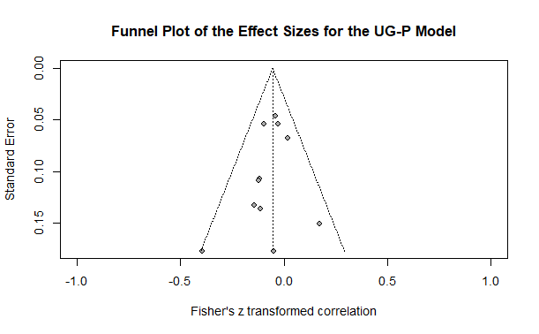

**Supplementary Materials 2-N**

**Moderator Analyses for the UG-P Meta-Analytic Model**

**Table 1**

*Simple Meta-Regression Predicting Effect Size from Study Sample Size (N)*

|  |  |  |  |  |  |  |
| --- | --- | --- | --- | --- | --- | --- |
| Variable | *b* | *SE* | *t* | *p* | 95% CI | |
|  |  |  |  |  | LL | UL |
| Intercept | -0.09 | 0.05 | -1.66 | .130 | -0.21 | 0.03 |
| Study *N* | 0.00 | 0.00 | 0.70 | .502 | 0.00 | 0.00 |

*Note*. The omnibus test for this moderator was not significant, *F*(1, 9) = 0.49, *p* = .502, *k* = 11. *b* = unstandardized regression coefficient; *SE* = standard error; *p* = p-value; CI = confidence interval; LL = lower limit; UL = upper limit.

**Table 2**

*Simple Meta-Regression Predicting Effect Size from Sex Composition of Study (Expressed as the Percentage of Female Participants)*

|  |  |  |  |  |  |  |
| --- | --- | --- | --- | --- | --- | --- |
| Variable | *b* | *SE* | *t* | *p* | 95% CI | |
|  |  |  |  |  | LL | UL |
| Intercept | -0.05 | 0.06 | -0.81 | .439 | -0.17 | 0.08 |
| Female Proportion | -0.02 | 0.11 | -0.20 | .846 | -0.28 | 0.24 |

*Note*. The omnibus test for this moderator was not significant, *F*(1, 9) = 0.04, *p* = .846, *k* = 11. *b* = unstandardized regression coefficient; *SE* = standard error; *p* = p-value; CI = confidence interval; LL = lower limit; UL = upper limit.

**Table 3**

*Simple Meta-Regression Predicting Effect Size from Average Sample Age in Study*

|  |  |  |  |  |  |  |
| --- | --- | --- | --- | --- | --- | --- |
| Variable | *b* | *SE* | *t* | *p* | 95% CI | |
|  |  |  |  |  | LL | UL |
| Intercept | -0.07 | 0.12 | -0.56 | .594 | -0.36 | 0.23 |
| Average Age | 0.00 | 0.01 | 0.01 | .991 | -0.01 | 0.01 |

*Note*. The omnibus test for this moderator was not significant, *F*(1, 6) = 0.00, *p* = .991, *k* = 8. *b* = unstandardized regression coefficient; *SE* = standard error; *p* = p-value; CI = confidence interval; LL = lower limit; UL = upper limit.

**Table 4**

*Simple Meta-Regression Predicting Effect Size from Sample Source*

|  |  |  |  |  |  |  |
| --- | --- | --- | --- | --- | --- | --- |
| Variable | *b* | *SE* | *t* | *p* | 95% CI | |
|  |  |  |  |  | LL | UL |
| Intercept | -0.12 | 0.09 | -1.39 | .202 | -0.31 | 0.08 |
| Student | 0.06 | 0.09 | 0.69 | .512 | -0.14 | 0.27 |
| Inmate | 0.20 | 0.14 | 1.38 | .206 | -0.13 | 0.53 |

*Note*. The omnibus test for this moderator was not significant, *F*(2, 8) = 0.96, *p* = .424, *k* = 11. Community samples were the reference category (i.e., the intercept). *b* = unstandardized regression coefficient; *SE* = standard error; *p* = p-value; CI = confidence interval; LL = lower limit; UL = upper limit.

**Table 5**

*Simple Meta-Regression Predicting Effect Size from Publication Status*

|  |  |  |  |  |  |  |
| --- | --- | --- | --- | --- | --- | --- |
| Variable | *b* | *SE* | *t* | *p* | 95% CI | |
|  |  |  |  |  | LL | UL |
| Intercept | -0.05 | 0.04 | -1.15 | .282 | -0.14 | 0.05 |
| Published | -0.01 | 0.05 | -0.22 | .829 | -0.13 | 0.10 |

*Note*. The omnibus test for this moderator was not significant, *F*(1, 9) = 0.05, *p* = .829, *k* = 11. Unpublished samples were the reference category (i.e., the intercept). *b* = unstandardized regression coefficient; *SE* = standard error; *p* = p-value; CI = confidence interval; LL = lower limit; UL = upper limit.

**Table 6**

*Simple Meta-Regression Predicting Effect Size from Psychopathy Measure Used*

|  |  |  |  |  |  |  |
| --- | --- | --- | --- | --- | --- | --- |
| Variable | *b* | *SE* | *t* | *p* | 95% CI | |
|  |  |  |  |  | LL | UL |
| Intercept | -0.05 | 0.04 | -1.11 | .304 | -0.15 | 0.05 |
| PCL | 0.13 | 0.12 | 1.03 | .336 | -0.16 | 0.42 |
| PPI | -0.07 | 0.09 | -0.82 | .437 | -0.28 | 0.14 |
| LSRP | -0.01 | 0.05 | -0.21 | .842 | -0.14 | 0.12 |

*Note*. The omnibus test for this moderator was not significant, *F*(3, 7) = 0.71, *p* = .575, *k* = 11. Samples using the Self Report Psychopathy Scale (and its successor versions) were the reference category (i.e., the intercept). *b* = unstandardized regression coefficient; *SE* = standard error; *p* = p-value; CI = confidence interval; LL = lower limit; UL = upper limit; PCL = Psychopathy Checklist; PPI = Psychopathic Personality Inventory; LSRP = Levenson Self-Report Psychopathy Scale.

**Table 7**

*Simple Meta-Regression Predicting Effect Size from Game Length (One-Shot vs. Iterated)*

|  |  |  |  |  |  |  |
| --- | --- | --- | --- | --- | --- | --- |
| Variable | *b* | *SE* | *t* | *p* | 95% CI | |
|  |  |  |  |  | LL | UL |
| Intercept | -0.05 | 0.02 | -1.92 | .086 | -0.10 | 0.01 |
| Iterated | -0.19 | 0.11 | -1.72 | .119 | -0.43 | 0.06 |

*Note*. The omnibus test for this moderator was not significant, *F*(1, 9) = 2.96, *p* = .119, *k* = 11. Samples with a one-shot game were the reference category (i.e., the intercept). *b* = unstandardized regression coefficient; *SE* = standard error; *p* = p-value; CI = confidence interval; LL = lower limit; UL = upper limit.

**Table 8**

*Simple Meta-Regression Predicting Effect Size from Perceived Opponent*

|  |  |  |  |  |  |  |
| --- | --- | --- | --- | --- | --- | --- |
| Variable | *b* | *SE* | *t* | *p* | 95% CI | |
|  |  |  |  |  | LL | UL |
| Intercept | -0.05 | 0.18 | -0.28 | .784 | -0.46 | 0.36 |
| Human | 0.00 | 0.18 | -0.02 | .986 | -0.41 | 0.41 |

*Note*. The omnibus test for this moderator was not significant, *F*(1, 8) = 0.00, *p* = .986, *k* = 10. Samples where participants were not led to believe that their opponent was human were the reference category (i.e., the intercept). *b* = unstandardized regression coefficient; *SE* = standard error; *p* = p-value; CI = confidence interval; LL = lower limit; UL = upper limit.

**Table 9**

*Simple Meta-Regression Predicting Effect Size from the Social Role of Opponents*

|  |  |  |  |  |  |  |
| --- | --- | --- | --- | --- | --- | --- |
| Variable | *b* | *SE* | *t* | *p* | 95% CI | |
|  |  |  |  |  | LL | UL |
| Intercept | -0.03 | 0.05 | -0.52 | .619 | -0.16 | 0.10 |
| Distant Member | -0.03 | 0.06 | -0.46 | .660 | -0.17 | 0.12 |

*Note*. The omnibus test for this moderator was not significant, *F*(1, 7) = 0.21, *p* = .660, *k* = 9. Samples where participants were told that their opponent was someone in their immediate social circle (e.g., friend, in-group member) were the reference category (i.e., the intercept). *b* = unstandardized regression coefficient; *SE* = standard error; *p* = p-value; CI = confidence interval; LL = lower limit; UL = upper limit.

**Table 10**

*Simple Meta-Regression Predicting Effect Size from the Incentive Structure of the Study*

|  |  |  |  |  |  |  |
| --- | --- | --- | --- | --- | --- | --- |
| Variable | *b* | *SE* | *t* | *p* | 95% CI | |
|  |  |  |  |  | LL | UL |
| Intercept | -0.05 | 0.18 | -0.28 | .789 | -0.50 | 0.40 |
| Participation Incentivized | -0.09 | 0.22 | -0.42 | .692 | -0.66 | 0.47 |
| Performance Incentivized | 0.01 | 0.18 | 0.05 | .961 | -0.45 | 0.47 |

*Note*. The omnibus test for this moderator was not significant, *F*(2, 5) = 0.28, *p* = .767, *k* = 8. Samples where participants were not incentivized were the reference category (i.e., the intercept). *b* = unstandardized regression coefficient; *SE* = standard error; *p* = p-value; CI = confidence interval; LL = lower limit; UL = upper limit.

**Supplementary Materials 2-O**

**Forest Plot for the Meta-Analytic Model Examining Psychopathy in the UG-Responder**

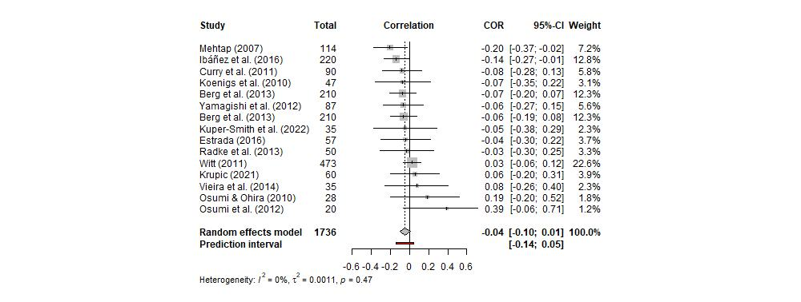

**Supplementary Materials 2-P**

**Funnel Plot for the UG-R Meta-Analytic Model**

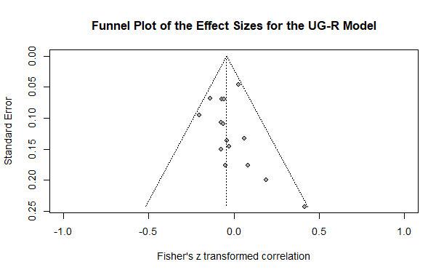

**Supplementary Materials 2-Q**

**Moderator Analyses for the UG-R Meta-Analytic Model**

**Table 1**

*Simple Meta-Regression Predicting Effect Size from Study Sample Size (N)*

|  |  |  |  |  |  |  |
| --- | --- | --- | --- | --- | --- | --- |
| Variable | *b* | *SE* | *t* | *p* | 95% CI | |
|  |  |  |  |  | LL | UL |
| Intercept | -0.07 | 0.05 | -1.57 | .140 | -0.17 | 0.03 |
| Study *N* | 0.00 | 0.00 | 0.78 | .452 | 0.00 | 0.00 |

*Note*. The omnibus test for this moderator was not significant, *F*(1, 13) = 0.60, *p* = .452, *k* = 15. *b* = unstandardized regression coefficient; *SE* = standard error; *p* = p-value; CI = confidence interval; LL = lower limit; UL = upper limit.

**Table 2**

*Simple Meta-Regression Predicting Effect Size from Sex Composition of Study (Expressed as the Percentage of Female Participants)*

|  |  |  |  |  |  |  |
| --- | --- | --- | --- | --- | --- | --- |
| Variable | *b* | *SE* | *t* | *p* | 95% CI | |
|  |  |  |  |  | LL | UL |
| Intercept | -0.02 | 0.07 | -0.25 | .809 | -0.16 | 0.13 |
| Female Proportion | -0.05 | 0.12 | -0.46 | .653 | -0.31 | 0.20 |

*Note*. The omnibus test for this moderator was not significant, *F*(1, 13) = 0.21, *p* = .653, *k* = 15. *b* = unstandardized regression coefficient; *SE* = standard error; *p* = p-value; CI = confidence interval; LL = lower limit; UL = upper limit.

**Table 3**

*Simple Meta-Regression Predicting Effect Size from Average Sample Age in Study*

|  |  |  |  |  |  |  |
| --- | --- | --- | --- | --- | --- | --- |
| Variable | *b* | *SE* | *t* | *p* | 95% CI | |
|  |  |  |  |  | LL | UL |
| Intercept | -0.06 | 0.11 | -0.52 | .615 | -0.32 | 0.20 |
| Average Age | 0.00 | 0.00 | 0.06 | .956 | -0.01 | 0.01 |

*Note*. The omnibus test for this moderator was not significant, *F*(1, 9) = 0.00, *p* = .956, *k* = 11. *b* = unstandardized regression coefficient; *SE* = standard error; *p* = p-value; CI = confidence interval; LL = lower limit; UL = upper limit.

**Table 4**

*Simple Meta-Regression Predicting Effect Size from Sample Source*

|  |  |  |  |  |  |  |
| --- | --- | --- | --- | --- | --- | --- |
| Variable | *b* | *SE* | *t* | *p* | 95% CI | |
|  |  |  |  |  | LL | UL |
| Intercept | -0.09 | 0.07 | -1.29 | .221 | -0.25 | 0.06 |
| Student | 0.06 | 0.08 | 0.77 | .455 | -0.11 | 0.23 |
| Inmate | 0.04 | 0.12 | 0.36 | .727 | -0.21 | 0.30 |

*Note*. The omnibus test for this moderator was not significant, *F*(2, 12) = 0.30, *p* = .745, *k* = 15. Community samples were the reference category (i.e., the intercept). *b* = unstandardized regression coefficient; *SE* = standard error; *p* = p-value; CI = confidence interval; LL = lower limit; UL = upper limit.

**Table 5**

*Simple Meta-Regression Predicting Effect Size from Publication Status*

|  |  |  |  |  |  |  |
| --- | --- | --- | --- | --- | --- | --- |
| Variable | *b* | *SE* | *t* | *p* | 95% CI | |
|  |  |  |  |  | LL | UL |
| Intercept | -0.04 | 0.05 | -0.76 | .463 | -0.14 | 0.07 |
| Published | -0.01 | 0.06 | -0.15 | .881 | -0.14 | 0.12 |

*Note*. The omnibus test for this moderator was not significant, *F*(1, 13) = 0.02, *p* = .881, *k* = 15. Unpublished samples were the reference category (i.e., the intercept). *b* = unstandardized regression coefficient; *SE* = standard error; *p* = p-value; CI = confidence interval; LL = lower limit; UL = upper limit.

**Table 6**

*Simple Meta-Regression Predicting Effect Size from Psychopathy Measure Used*

|  |  |  |  |  |  |  |
| --- | --- | --- | --- | --- | --- | --- |
| Variable | *b* | *SE* | *t* | *p* | 95% CI | |
|  |  |  |  |  | LL | UL |
| Intercept | -0.04 | 0.06 | -0.75 | .472 | -0.17 | 0.08 |
| PCL | -0.01 | 0.11 | -0.08 | .939 | -0.26 | 0.24 |
| PPI | -0.02 | 0.08 | -0.25 | .805 | -0.21 | 0.17 |
| LSRP | -0.01 | 0.08 | -0.18 | .860 | -0.20 | 0.17 |
| TriPM | 0.12 | 0.19 | 0.64 | .537 | -0.31 | 0.56 |
| SD3 | 0.10 | 0.15 | 0.66 | .529 | -0.25 | 0.45 |

*Note*. The omnibus test for this moderator was not significant, *F*(5, 9) = 0.22, *p* = .944, *k* = 15. Samples using the Self Report Psychopathy Scale (and its successor versions) were the reference category (i.e., the intercept). *b* = unstandardized regression coefficient; *SE* = standard error; *p* = p-value; CI = confidence interval; LL = lower limit; UL = upper limit; PCL = Psychopathy Checklist; PPI = Psychopathic Personality Inventory; LSRP = Levenson Self-Report Psychopathy Scale; TriPM = Triarchic Psychopathy Measure; SD3 = Short Dark Triad.

**Table 7**

*Simple Meta-Regression Predicting Effect Size from Game Length (One-Shot vs. Iterated)*

|  |  |  |  |  |  |  |
| --- | --- | --- | --- | --- | --- | --- |
| Variable | *b* | *SE* | *t* | *p* | 95% CI | |
|  |  |  |  |  | LL | UL |
| Intercept | -0.05 | 0.03 | -1.85 | .087 | -0.12 | 0.01 |
| Iterated | 0.20 | 0.12 | 1.60 | .133 | -0.07 | 0.47 |

*Note*. The omnibus test for this moderator was not significant, *F*(1, 13) = 2.57, *p* = .133, *k* = 15. Samples with a one-shot game were the reference category (i.e., the intercept). *b* = unstandardized regression coefficient; *SE* = standard error; *p* = p-value; CI = confidence interval; LL = lower limit; UL = upper limit.

**Table 8**

*Simple Meta-Regression Predicting Effect Size from Perceived Opponent*

|  |  |  |  |  |  |  |
| --- | --- | --- | --- | --- | --- | --- |
| Variable | *b* | *SE* | *t* | *p* | 95% CI | |
|  |  |  |  |  | LL | UL |
| Intercept | -0.04 | 0.06 | -0.72 | .487 | -0.17 | 0.09 |
| Human | 0.00 | 0.07 | -0.02 | .986 | -0.15 | 0.15 |

*Note*. The omnibus test for this moderator was not significant, *F*(1, 13) = 0.00, *p* = .986, *k* = 15. Samples where participants were not led to believe that their opponent was human were the reference category (i.e., the intercept). *b* = unstandardized regression coefficient; *SE* = standard error; *p* = p-value; CI = confidence interval; LL = lower limit; UL = upper limit.

**Table 9**

*Simple Meta-Regression Predicting Effect Size from the Incentive Structure of the Study*

|  |  |  |  |  |  |  |
| --- | --- | --- | --- | --- | --- | --- |
| Variable | *b* | *SE* | *t* | *p* | 95% CI | |
|  |  |  |  |  | LL | UL |
| Intercept | -0.05 | 0.18 | -0.27 | .791 | -0.45 | 0.35 |
| Participation Incentivized | 0.01 | 0.19 | 0.05 | .963 | -0.42 | 0.44 |
| Performance Incentivized | 0.00 | 0.19 | -0.02 | .986 | -0.42 | 0.41 |

*Note*. The omnibus test for this moderator was not significant, *F*(2, 11) = 0.01, *p* = .986, *k* = 14. Samples where participants were not incentivized were the reference category (i.e., the intercept). *b* = unstandardized regression coefficient; *SE* = standard error; *p* = p-value; CI = confidence interval; LL = lower limit; UL = upper limit.

**Supplementary Materials 2-R**

**Forest Plot for the Meta-Analytic Model Examining Psychopathy in the TG-Proposer**

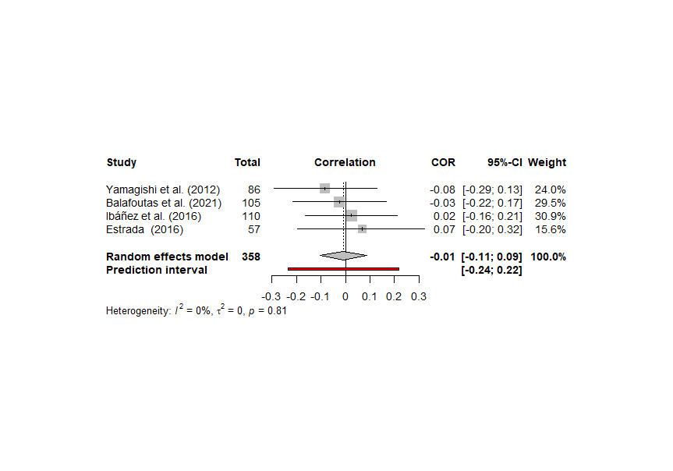

**Supplementary Materials 2-S**

**Funnel Plot for the TG-P Meta-Analytic Model**

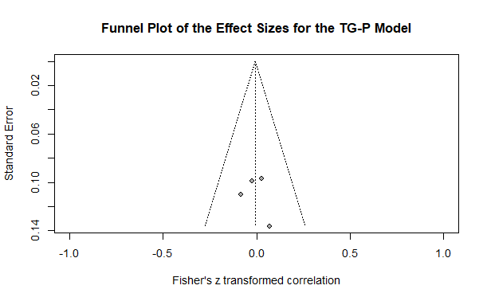

**Supplementary Materials 2-T**

**Forest Plot for the Meta-Analytic Model Examining Psychopathy in the TG-Responder**

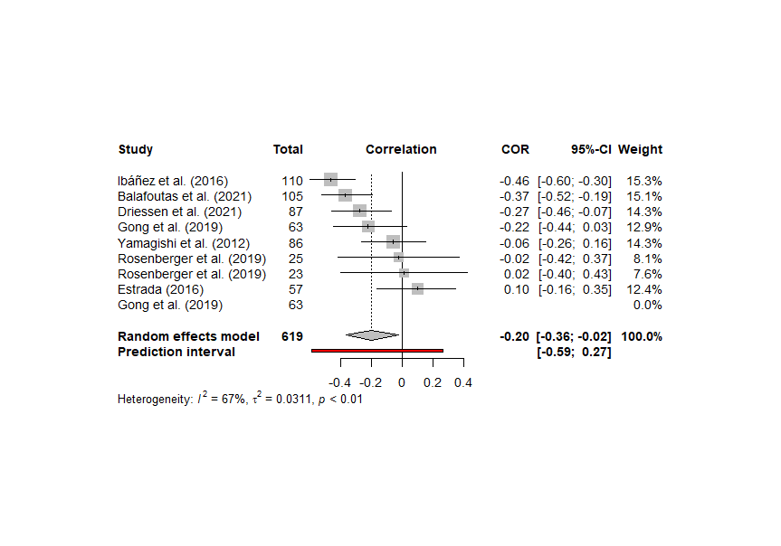

**Supplementary Materials 2-U**

**Funnel Plot for the TG-R Meta-Analytic Model**

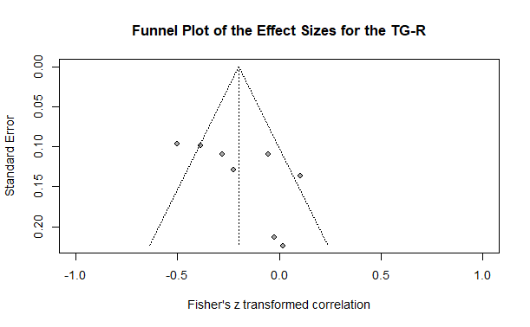

**Supplementary Materials 2-V**

**Forest Plot for the Meta-Analytic Model Examining Psychopathy and Success in the PDG**

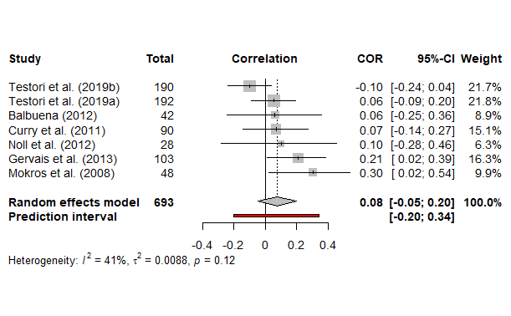

**Supplementary Materials 2-W**

**Funnel Plot for the Psychopathy and Success in the PDG Model**

